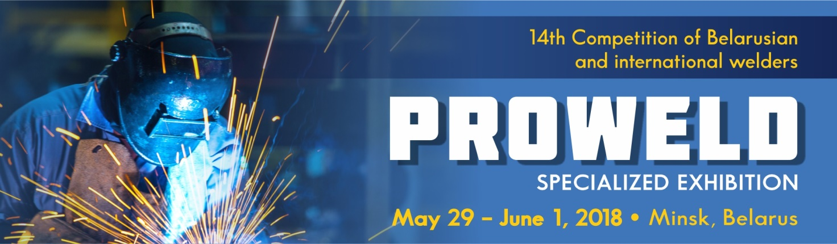

ABOUT THE EXHIBITION

**INFORMATION LETTER**

We invite you to participate in **the international exhibition PROWELD**, which will take place on May 29 – June 1, 2018 at the same time and place with **14th Competition of Belarusian ad international welders** (Minsk, Belarus, 20/2 Pobediteley av., Roofed Soccer Arena).

**EXHIBITION SECTORS:**

|  |  |
| --- | --- |
| * Welding equipment * Power supplies, tools and accessories for welding * Parts, accessories and supplies for welding equipment * Materials for welding and allied processes * Equipment for the surface preparation | * Chemistry for metal processing * Equipment for quality control of weld joints * Welder overalls, personal protective equipment * Collective security systems during welding, ventilation and filter systems |

**Participants of welder’s Competition 2010-2017**

In 2018 the Competition will be held in 6 nominations:

|  |  |
| --- | --- |
| * **А**(135). **Mechanized welding**; * **Б**(141). **Argon arc welding**; * **В-1**(111). **Manual arc welding (pipe welding)**; | * **В-2**(111). **Manual arc welding (reinforcing bars welding)** * **Г** (311). **Manual gas (acetylene-oxygen) welding** * **Creative welding** |

The Ministry of Industry, the Ministry of Architecture, the Ministry of Energy, the Ministry of Education, the Ministry of Housing and Communal Services, the concern Belneftekhim, the National Academy of Sciences of Belarus, and the organizations without departmental subordination take part in the competition.

Visitors: the main welders, the main technologists, engineers, specialists in the organization of welding production at the enterprises of machine building, energy, oil and gas industry, metallurgy, construction, housing and communal services, railway complex and on the basis of vocational schools.

Details about the welders Competition can be found.

You can get acquainted with the list of participating Companies [**here**](https://www.expoforum.by/exhibitions/?SECTION_ID=2561).

**Quantity of welders by departmental subordination of organizations participating in the competition, 2017**

**BUSINESS PROGRAM OF THE EXHIBITION-PRESENTATION:**

Breakout session "Efficient welding and related technologies in the Republic of Belarus";

The business program still is developing and can be amended.

**International exhibition PROWELD and 14th Competition of Belarusian and international welders** are the events of [**Belarusian Industrial Forum**](https://expoforum.by/en/exhibitions/?SECTION_ID=2701) 2018 (May 29 - June 1, 2018) within framework of which will be held 21st international exhibition [**TechInnoProm**](https://expoforum.by/en/exhibitions/?SECTION_ID=2682). At the same time and place also will be held 17th international exhibition [**Chemistry. Oil & Gas**](https://expoforum.by/en/exhibitions/?SECTION_ID=2689), 2nd international exhibition [**PLASTEC**](https://expoforum.by/en/exhibitions/?SECTION_ID=2761).

**ORGANIZER:**

EXPOFORUM Exhibition Company

91 Pritytskogo str., office 432, 220140 Minsk, Belarus

[www.expoforum.by](http://www.expoforum.by/en/)

**CONTACTS:**

Nicolaévich Alexander, Head of International Department

+375 17 314 34 38, e-mail: [global@expoforum.by](mailto:global@expoforum.by)